IBM Nalaiyathiran

Data Analytics: Assignment 1

Link to Implementation

<https://us3.ca.analytics.ibm.com/bi/?perspective=explore&pathRef=.my_folders%2FTarun%2Bexploration&subView=model000001834200c92e_00000001>

Exploration 1:

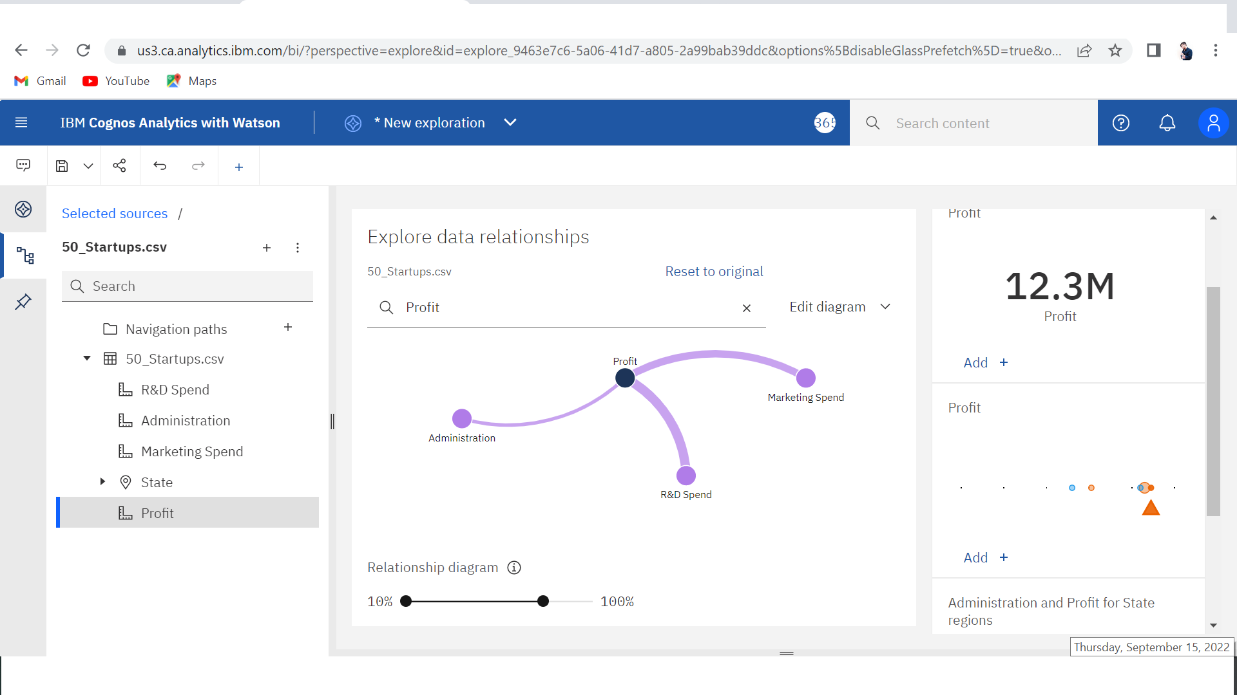

Exploration 2:

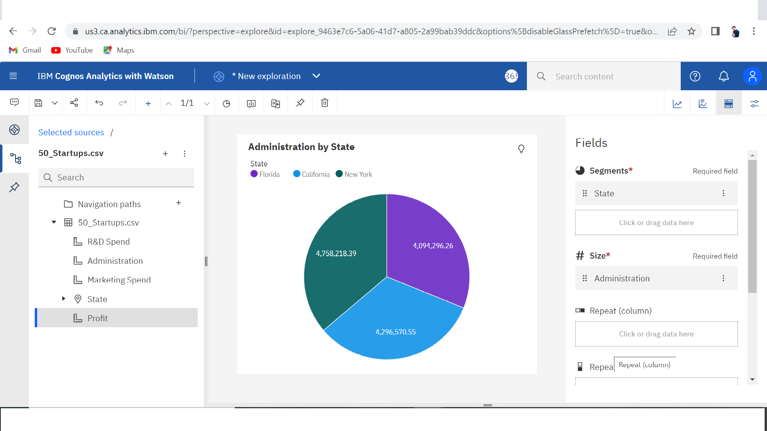

Exploration 3:

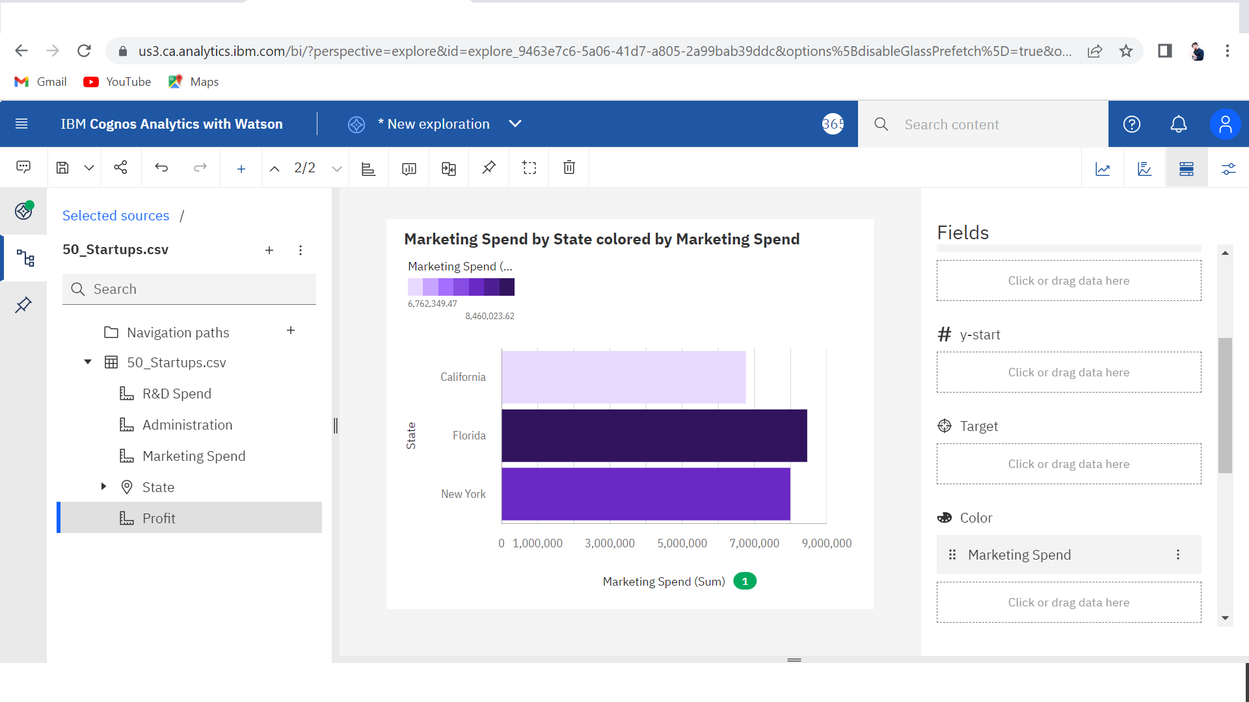

Exploration 4:

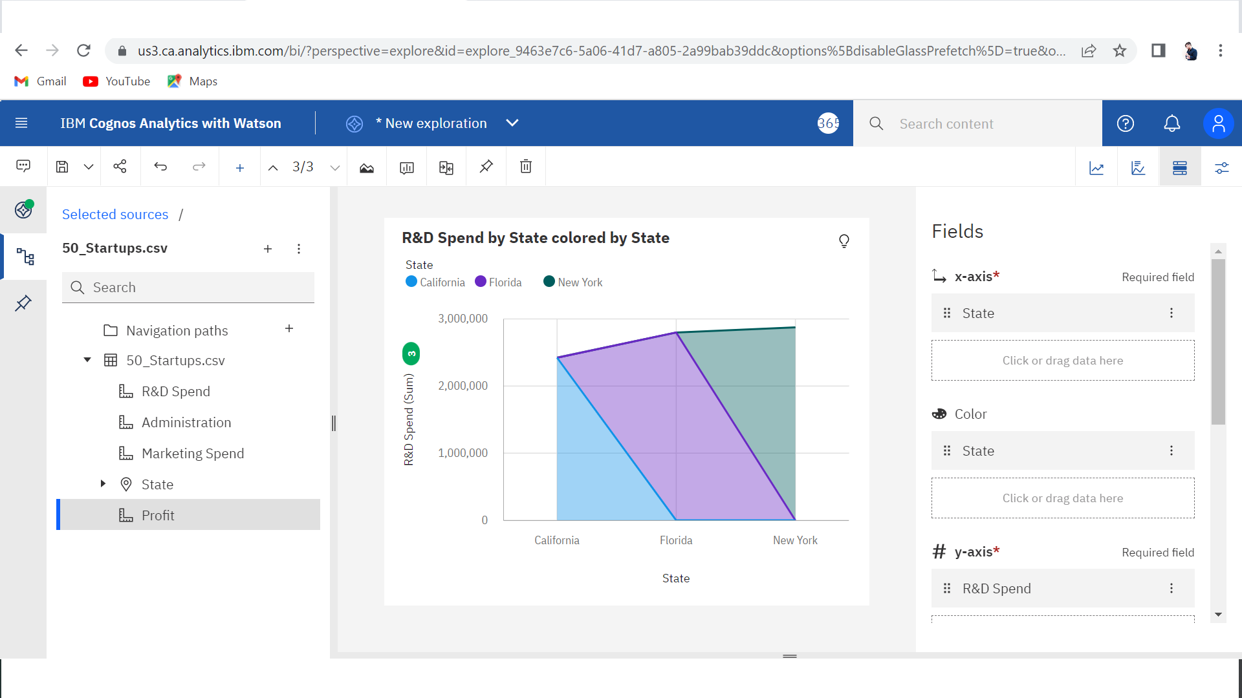

Exploration 5:

